EXPERIMENT – 1
BASIC IMAGE PROCESSING USING OPENCV IN PYTHON
AIM
To develop a Python program using the OpenCV library to read and display an image using basic image processing operations.
SOFTWARE REQUIREMENTS
- Python 3.x
- OpenCV (cv2) library
- Notepad
- Command Prompt
- Windows Operating System
ALGORITHM
- Start the program.
- Import the OpenCV library using cv2.
- Read the image flower.jpg using cv2.imread().
- Check whether the image has been loaded successfully.
- Display the image using cv2.imshow().
- Wait for a keyboard input using cv2.waitKey().
- Close all OpenCV windows using cv2.destroyAllWindows().
- Stop the program.
PROCEDURE
- Install Python on the computer.
- Install the OpenCV library using Command Prompt.
- Create a folder named opencv on the Desktop.
- Open Notepad and type the Python program.
- Save the program as image_processing.py inside the opencv folder.
- Save the required image as flower.jpg inside the same folder.
- Open Command Prompt.
- Navigate to the Desktop using the command:
cd Desktop
- Enter the OpenCV folder using the command:
cd opencv
- Execute the Python program using:
python image_processing.py
- The flower.jpg image is displayed in a separate window.
- Press any key to close the image window.
- Verify the output.
PROGRAM
import cv2
image = cv2.imread("flower.jpg")
if image is None:
print("Image not found")
else:
cv2.imshow("Flower Image", image)
cv2.waitKey(0)
cv2.destroyAllWindows()
COMMANDS USED
To install OpenCV:
pip install opencv-python
To move to the Desktop:
cd Desktop
To enter the OpenCV folder:
cd opencv
To execute the Python program:
python image_processing.py
EXPLANATION OF THE PROGRAM
import cv2
This statement imports the OpenCV library into the Python program.
cv2.imread("flower.jpg")
This function reads the flower.jpg image from the current folder.
if image is None:
This condition checks whether the image was loaded successfully.
print("Image not found")
This statement displays an error message if the image cannot be found.
cv2.imshow("Flower Image", image)
This function displays the loaded image in a window with the title Flower Image.
cv2.waitKey(0)
This function waits until the user presses a keyboard key.
cv2.destroyAllWindows()
This function closes all OpenCV windows.
INPUT
The input to the program is the image file: 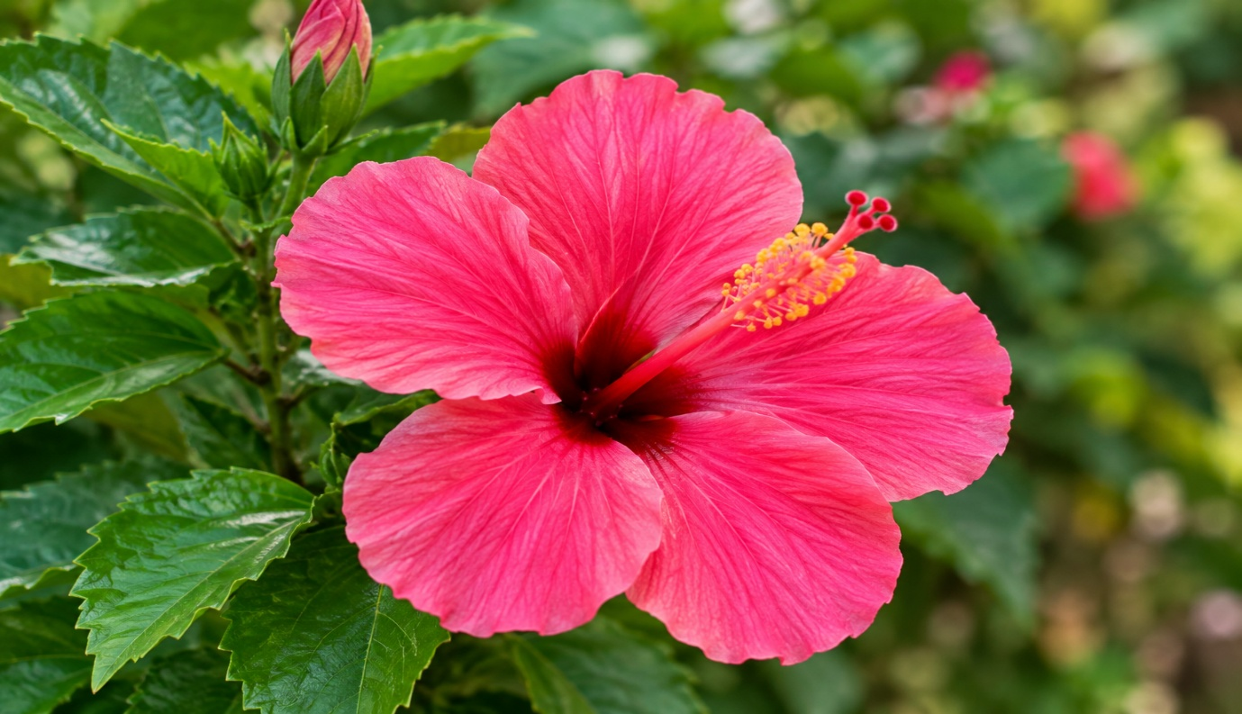
flower.jpg

OUTPUT
The flower.jpg image is successfully read using OpenCV and displayed in a separate window.
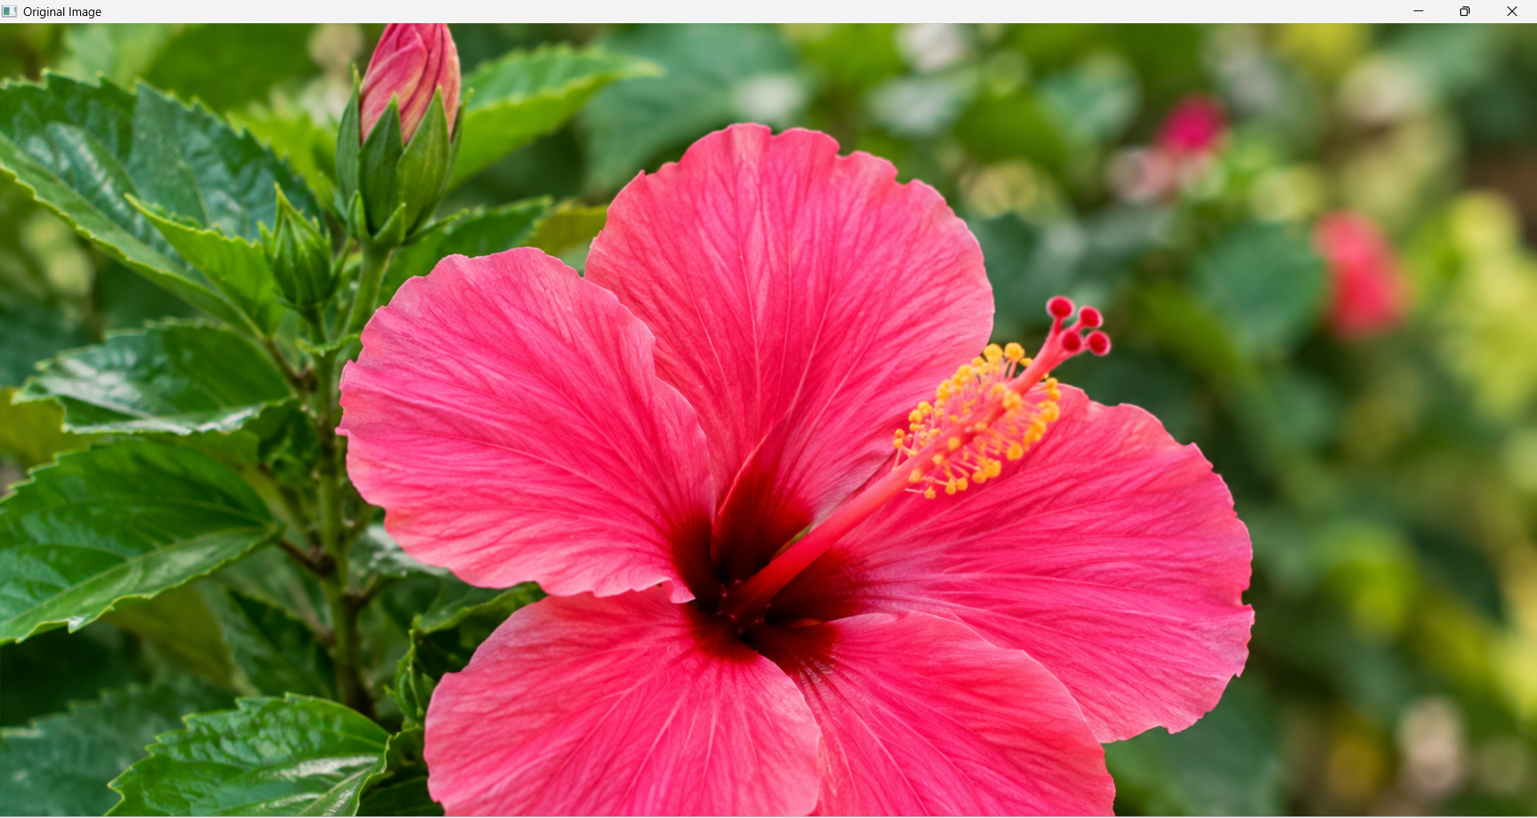
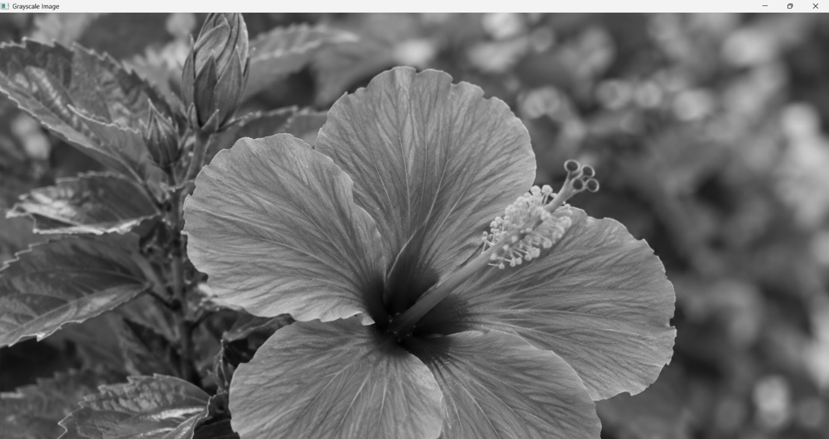
RESULT
Thus, the Python program for reading and displaying an image using OpenCV was successfully executed, and the flower.jpg image was displayed successfully.

